1. Project Title: API development of SweetSpot - Delivering Delight to Your Doorstep.
2. **Project Statement and Outcomes:**
3. The goal of this project is to design and implement a computerized e-commerce platform, SweetSpot, dedicated to cake delivery services using Python. The platform will offer customers the convenience of ordering customized cakes online and tracking their deliveries in real-time. SweetSpot aims to revolutionize the cake delivery industry by offering a comprehensive online platform that simplifies the process of ordering customized cakes and ensures timely delivery.
4. The implementation of SweetSpot, an e-commerce platform for cake delivery services using Python, aims to enhance customer satisfaction, streamline business operations, and establish a strong brand presence. By offering online ordering, customization, and real-time delivery tracking, SweetSpot aims to revolutionize the cake delivery industry. Through automation of processes like order management and inventory tracking, the platform seeks to improve operational efficiency. Ultimately, SweetSpot aims to become a leading player in the market, driven by its innovative approach and commitment to customer delight.
5. **Modules to be Implemented:**

* Online Ordering and Customization Module
* Delivery Tracking Module
* Store Management Module
* Review, Bug Fixes, Documentation

1. **Week-wise module implementation and high-level requirements:**

* Week 1-2:

Module Implementation - Online Ordering and Customization Module

High-level Requirements:

* Develop a user-friendly interface for customers to browse cake options and customize their orders.
* Implement a secure payment gateway for online transactions using Python frameworks like Django or Flask.
* Incorporate features for customers to select cake ingredients, design, size, and other customization options.
* Ensure seamless integration of the customization feature with the ordering process.
* Week 3-4:

Module Implementation - Delivery Tracking Module

High-level Requirements:

* Integrate a real-time tracking system using Python libraries like Django Channels or Flask-SocketIO that allows customers to monitor the status of their orders from placement to delivery.
* Provide notifications and updates to customers regarding order status changes and estimated delivery times.
* Ensure compatibility with various devices and browsers for optimal user experience.
* Week 5-6:

Module Implementation - Store Management Module

High-level Requirements:

* Develop a flexible system for managing store listings in different cities across India using Python ORM (Object-Relational Mapping) tools.
* Implement features for administrators to add, edit, or remove store locations as needed.
* Ensure seamless synchronization of inventory and order management across all store locations.
* Provide robust reporting and analytics tools to monitor store performance and customer trends.
* Week 7-8:Review, Bug Fixes, Documentation

High-level Requirements:

* Conduct a thorough review of the entire system, including functionality, security, and user interface.
* Address any identified bugs or issues and perform necessary fixes.
* Prepare comprehensive documentation covering system architecture, user guides, and technical specifications.

1. **Diagrams:**

* 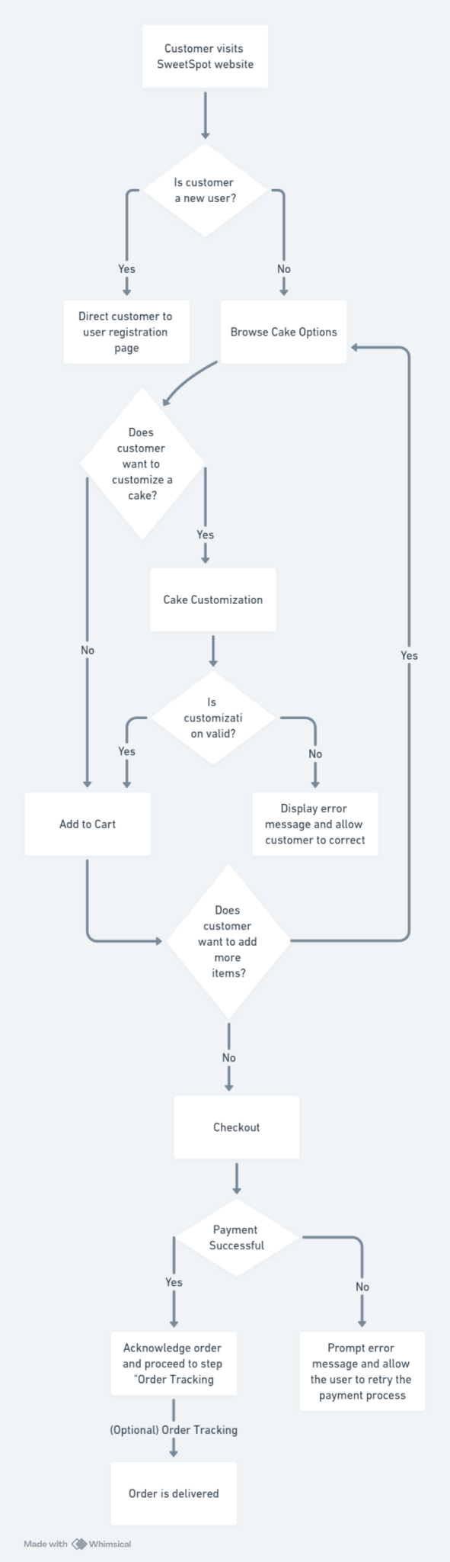Flowchart

1. **Output:**

* REST API Endpoints for Registration, login, logout, payments and notifications.
* REST API Endpoints that can handle Create, Retrieve, Update, Delete Cakes, Orders, Stores data